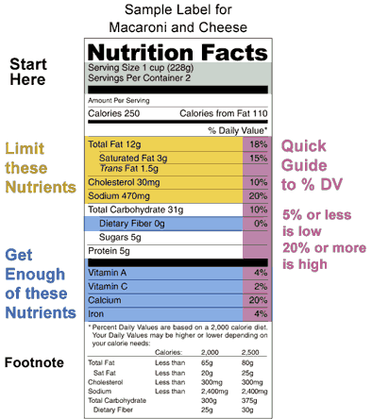

Food Label Quiz

1. Name one of the minerals listed.
2. What major nutrient isn’t listed?
3. How many total calories are in this container?
4. If you consumed 1.5 servings of this item, how many mg. of sodium would you consume?
5. T or F The FDA doesn’t require food labeling on packaged foods.
6. Do you think this is a healthy food item? Why?
7. What popular food do you think this is?
8. List the major nutrients in the order located on the food label